**SOLUTION OVERVIEW**

Before deciding between HDB loan or any bank loans, potential home buyers need to understand their financial capabilities. Our team believes in **making it easy for home buyers to make loan decisions**.

Our solution follows three main guidelines:

1. Empowers home buyers to make a sensible loan decision
2. Do not overwhelm buyers with unnecessary information
3. Do not deviate from CITIBANK’s core business function

Our application has three main functions:

|  |  |  |
| --- | --- | --- |
|  | Functionalities | Purpose |
| 1 | Home Loan Calculator | Evaluate loan plans based on their eligibility and affordability |
| 2 | Property Search | Search and view details on suitable properties |
| 3 | Property Comparison | Compare among various properties |

1. **HOME LOAN CALCULATOR**

Based on the inputs of potential buyers, we help them to assess their financial capability and eligibility to take a house loan. In the shortest time, buyers can derive maximum loan and monthly repayment amount. Our home loan calculator is built based on these models:

Maximum Loan Model

In view of MAS’s Housing Loan Rules, our model incorporates potential buyers’ Loan-To-Value (LTV) limit. Maximum loan amount would be the multiplication of **LTV** and **valuation limit** of property chosen.

LTV varies based on several scenarios:

|  |  |  |  |
| --- | --- | --- | --- |
| Scenario / LTV (%) | No. of Existing Home Loan | | |
| 0 | 1 | 2 |
| If buyer is purchasing an HDB flat,   * Loan Tenure < 25 years AND * Sum (Loan Tenure and Buyer’ Age) <= Retirement age of 65   If buyer is purchasing private property,   * Loan Tenure < 30 years AND * Sum (Loan Tenure and Buyer’ Age) <= Retirement age of 65 | 75% | 45% | 35% |
| If buyer is purchasing an HDB flat,   * Loan Tenure > 25 years OR * Sum (Loan Tenure and Buyer’ Age) > Retirement age of 65   If buyer is purchasing private property,   * Loan Tenure > 30 years OR * Sum (Loan Tenure and Buyer’ Age) > Retirement age of 65 | 55% | 25% | 15% |

Monthly Repayment Model

We understand that bank loan interest rate is subjected to changes after the first 1-3 years.

For our calculation, we made the following assumptions:

* + Fixing interest rate at 1.7%
  + Assume payments are made at the end of the month

Our formula follows the PMT function in Excel, taking maximum loan amount as present value, loan tenure as no. of periods and interest rate to be 1.7%.

Maximum CPF Withdrawal Model

There is a minimum requirement for Basic Retirement Sum (BRS) in CPF OA account before buyers withdraw all CPF funds for house payment. As such, we calculate the amount of maximum CPF remaining for house payment upon applying the rules.

|  |  |
| --- | --- |
| Age | Basic Retirement Sum in OA |
| 57 and above | $80,500 |
| 56 | $83,000 |
| 55 | $85,500 |
| 54 | $88,000 |
| 53 and below | $90,000 |

The formula we use for Maximum CPF Withdrawal follows these rules:

|  |  |  |
| --- | --- | --- |
|  | Scenarios | Calculations |
| 1 | CPF declared is lower than Valuation Limit | Max. CPF amount = Valuation Limit |
| 2 | CPF declared is higher than Valuation Limit | Max. CPF amount = CPF amount declared – BRS |

Max. CPF amount should not exceed Withdrawal Limit which is set at 120% of Valuation Limit.

Eligibility Model

Our Eligibility model considers two factors: **Total Debt Service Ratio (TSDR)** and **Mortgage Servicing Ratio (MSR).**

* + Rule 1: Net Debt / Net Income < TDSR
  + Rule 2: Monthly Repayment Amount < MSR x Gross Income

TSDR of potential buyers is determined by its income level:

|  |  |
| --- | --- |
| Income (S$) | Allowable TSDR (of Net Income) |
| 3000 | 60% |
| 6000 | 70% |
| 10,000 | 75% |
| > 10, 000 | 80% |

Our solution maximizes transparency while populating eligibility reports to potential buyers. Instead of plainly informing buyers their eligibility, we also provide breakdown of the various requirement for eligibility: **TDSR** and **MSR**.

Buyers can experiment with our house loan calculator to derive the financial conditions before taking up a suitable loan for their desired properties.

1. **PROPERTY SEARCH FUNCTION**

Our team utilizes iProperty search engine to help us populate the real-time information of available apartment listings. Our Property Search Function returns the data fetched by the search engine.

It displays basic information such as property’s street address, selling price and HDB type. It also retrieves agent name and company details. If there is no available property based on the conditions specified by potential buyers, the function would return “No property found”. In cases where search is taking too long, clear the browser cache or using Incognito to load.

Now that we inform potential buyers the list of available properties and prices, we want to encourage them to use the property compare function to evaluate which property suits their liking the most.

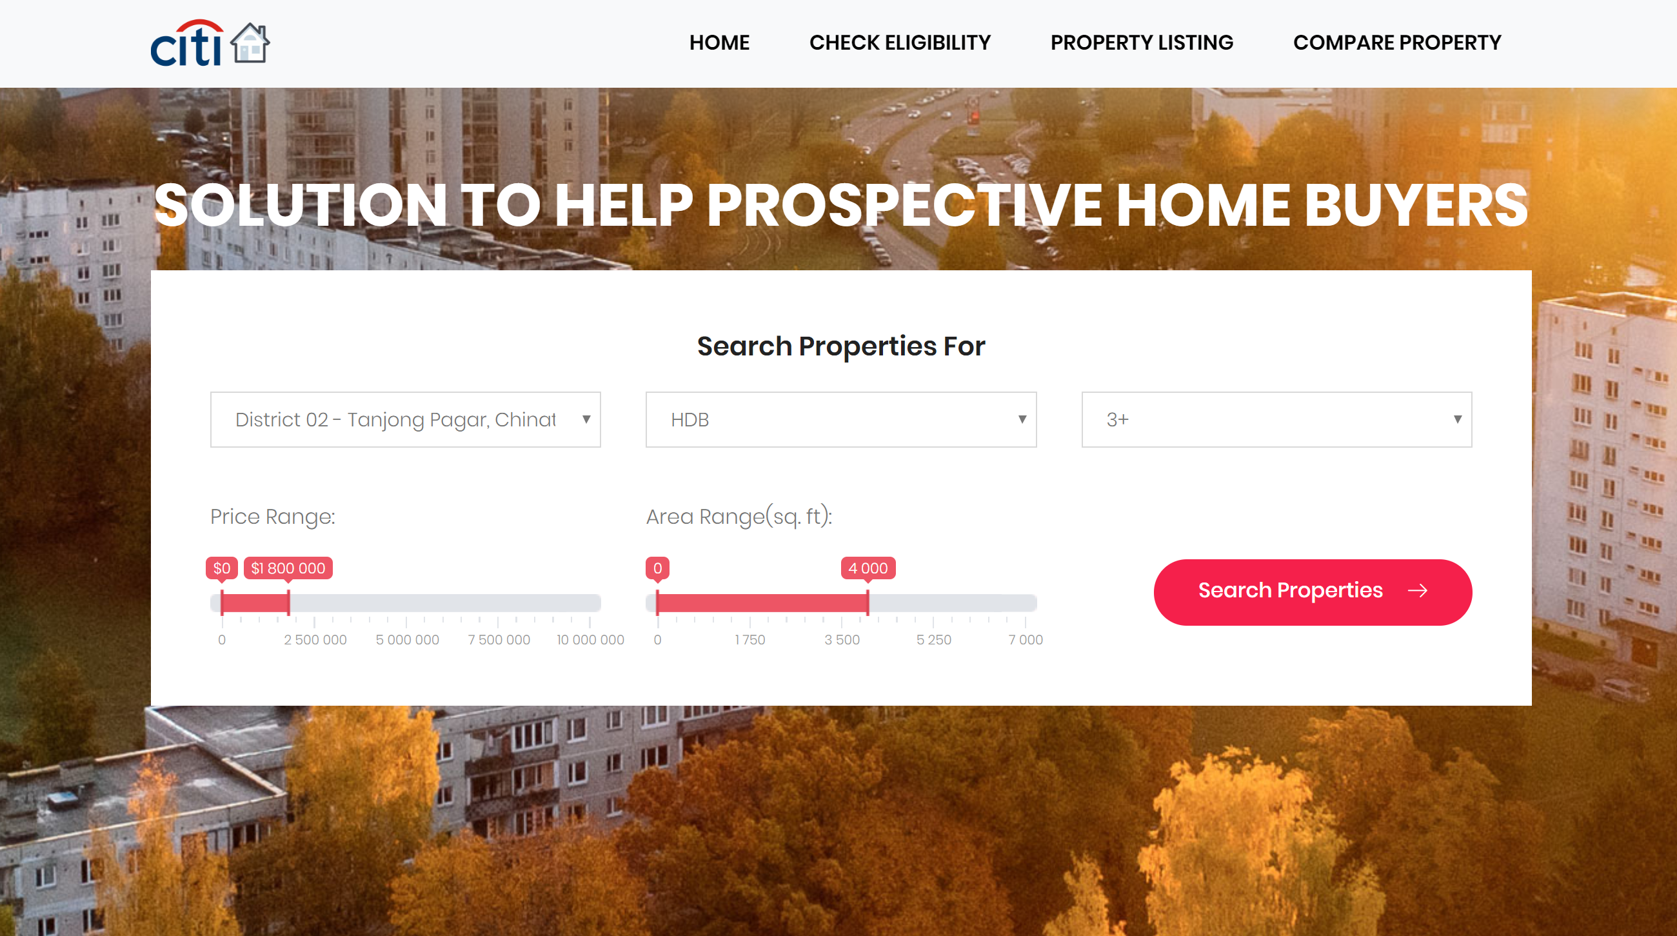

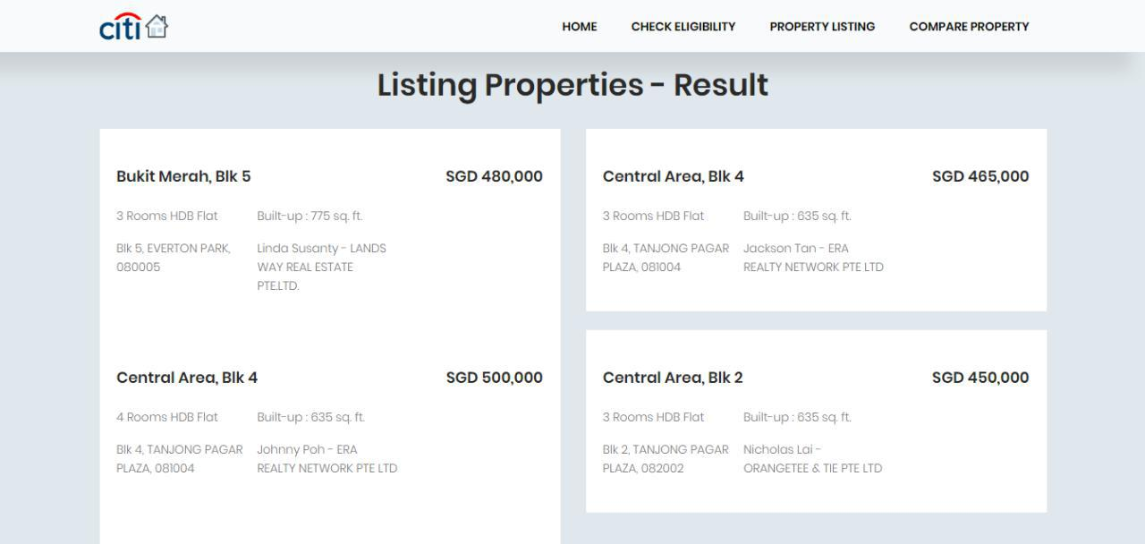

1. **PROPERTY COMPARE FUNCTION**

The Property Compare function utilize the squarefoot.com.sg API to compare property A and property B. By inputting the postal codes, we can retrieve a detailed comparison analysis between properties. The summary statistics of properties should be displayed unless there is no sale transaction in the past 6 months.

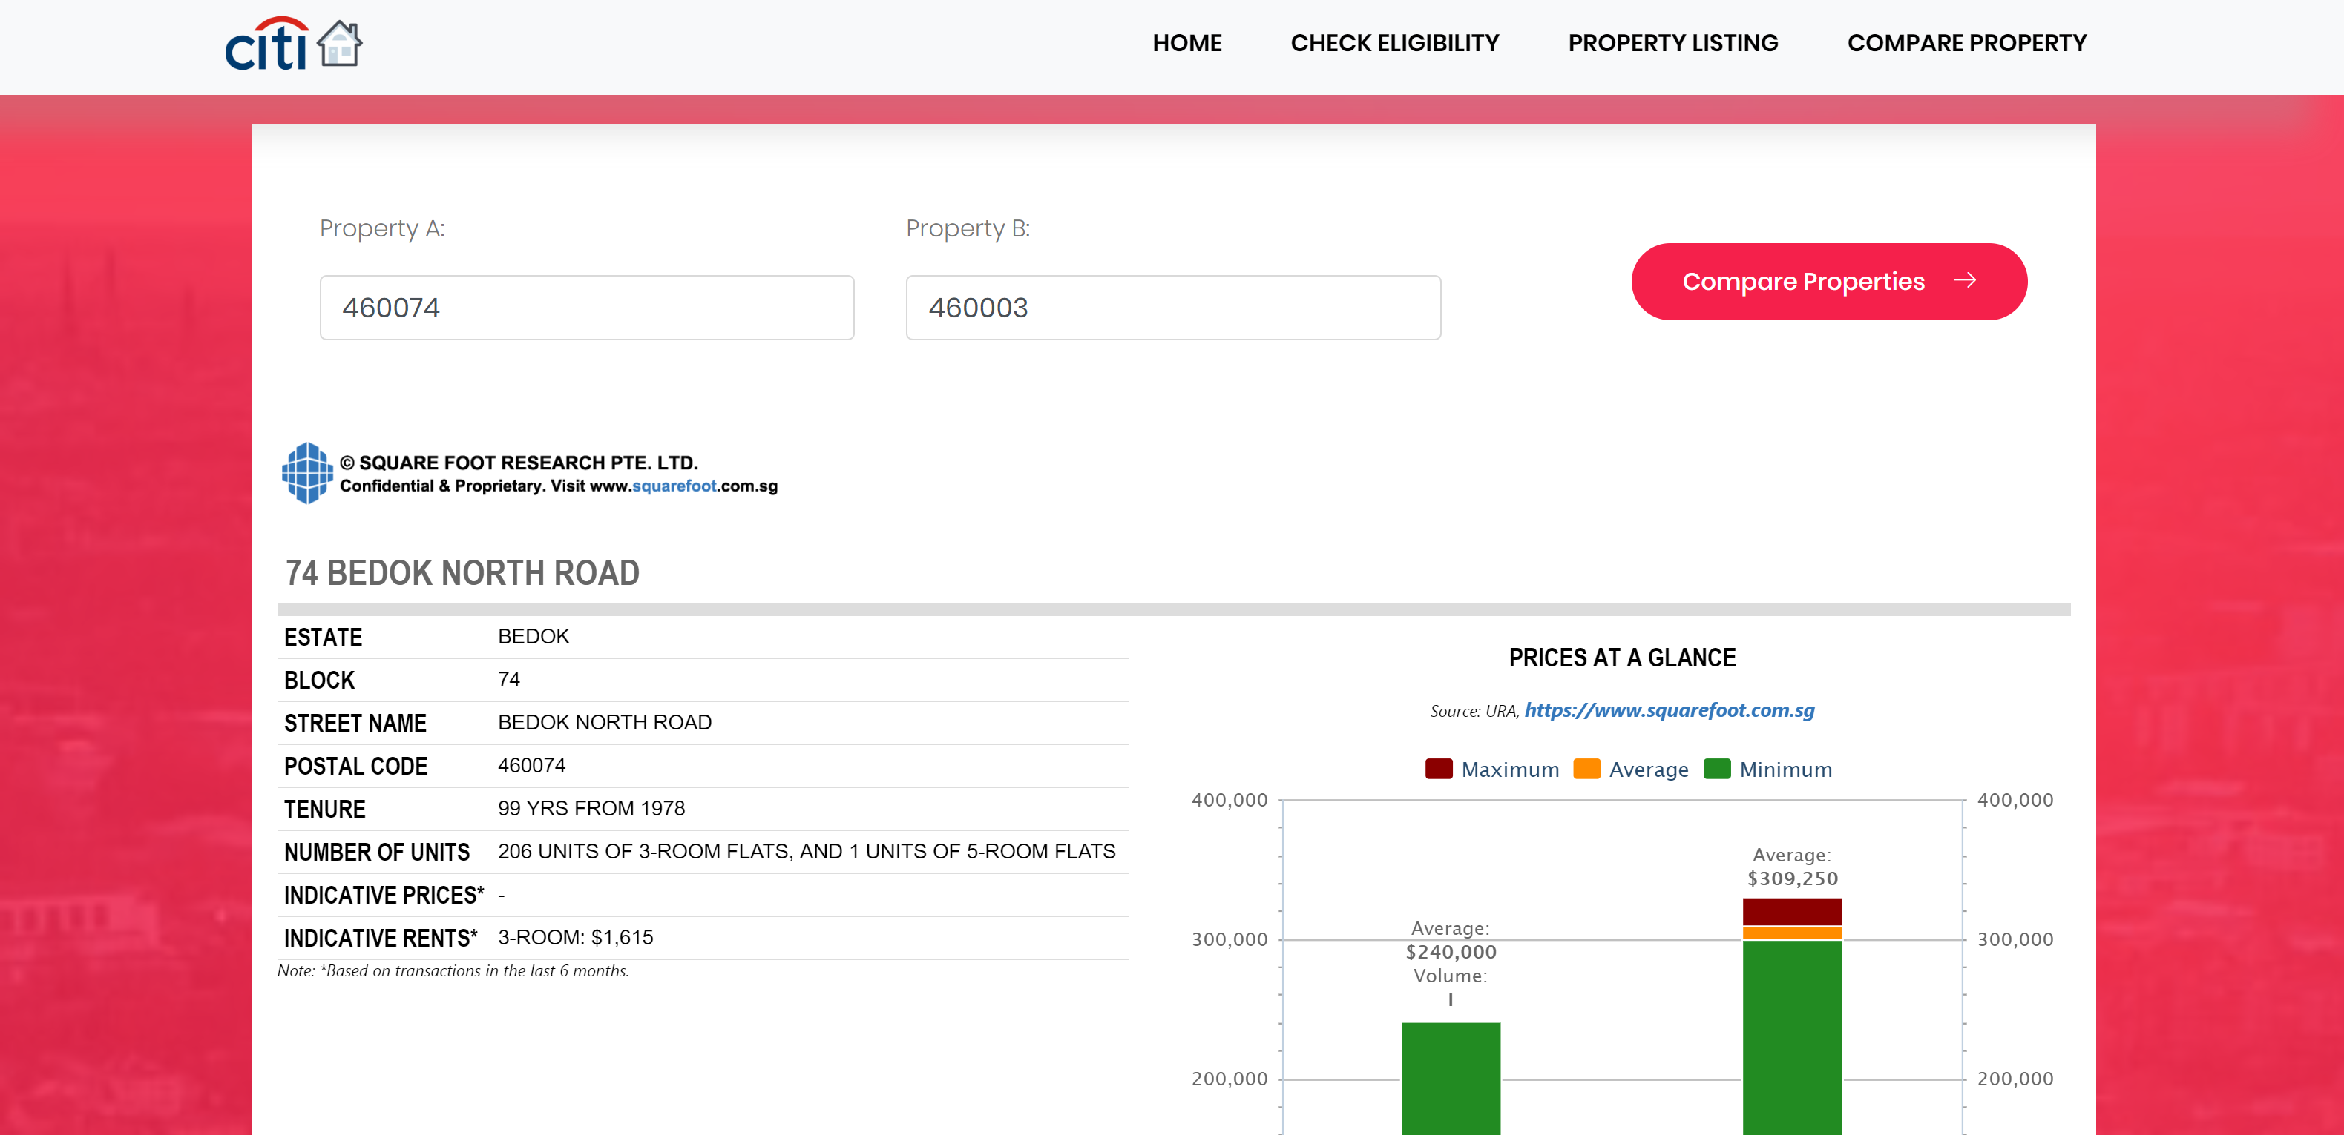

With a suitable property in mind, potential buyers can experiment the property figures with the house loan calculator again. Now, they can include the valuation limit and run the eligibility report.

**CONCLUSION**

The flow of this use case is to guide closely the thinking process of prospective buyers who are clueless towards their choice of property and type of loans. Instead of plainly display information, our team helps buyers to understand the gap between the cost of their dream home and their financial affordability. As such, we align and manage their expectations.

All in all, we want them to feel confident and certain of their decisions before proceeding to take a loan. By keeping information transparent and readily accessible, we want to cultivate the invaluable trust with our potential clients not only in the application but most importantly our CITIBANK products.

**Technical Diagram**

